|  |  |  |
| --- | --- | --- |
|  | **ST. FRANCIS INSTITUTE OF TECHNOLOGY**  **Mount Poinsur, Borivali (West), Mumbai-400103**  **Department of Information Technology**  **Information Technology Students’ Association (ITSA)**  **Full-Stack Web Development Workshop.**    Date: -20th March 2021  Time: -4:00 p.m.- 6:00p.m.  Platform: -Google Meet  No. of Participants: - 50 |  |

After the Debate Competition and the workshop on Ethical Hacking, ITSA was ready with their next workshop. This workshop was all about Full-Stack Web Development. This workshop was held on the 20th of March 2021 and via Google Meet.

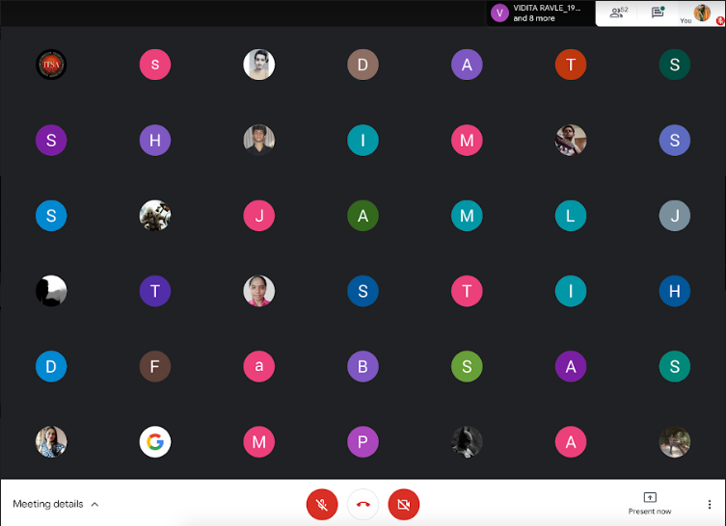

Our Technical Head, Mr. Mukunda welcomed everyone and introduced our resource person for the day Ms. Sonali Munagekar. After that, he also gave some basic instructions and explained the webinar’s flow. The workshop started with the quote Journey of the Web. Then she explained about the Traditional Web applications, how the consumers then were limited and most of which were PC. She also told us about the modern web applications and how it has a huge number of consumers.

The main topics that were covered included:-

* Modern Scalable Architecture.
* Cloud-based Architecture.
* API-REST Endpoints- (i) Get Request, (ii) Post Request.
* Modern Full-Stack Applications (Mongo DB, Express, REACT, Node.js)
* Spring Boot:- Provides additional Library.

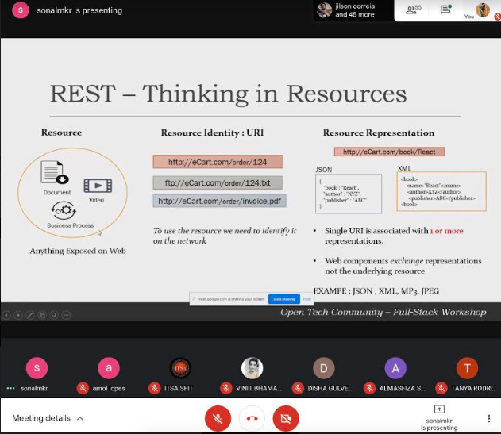

Ma’am also said we’ll see how REACT works and what it does and after that start developing. Then she showed us an application using REACT. REACT is a single-page application.

The resource person provided a GitHub link for the referral and future use for the students.

The main parts that were discussed about REACT were:-

* Components and State
* State Complexity

Then she explained the Backend Node.js and showed the development.

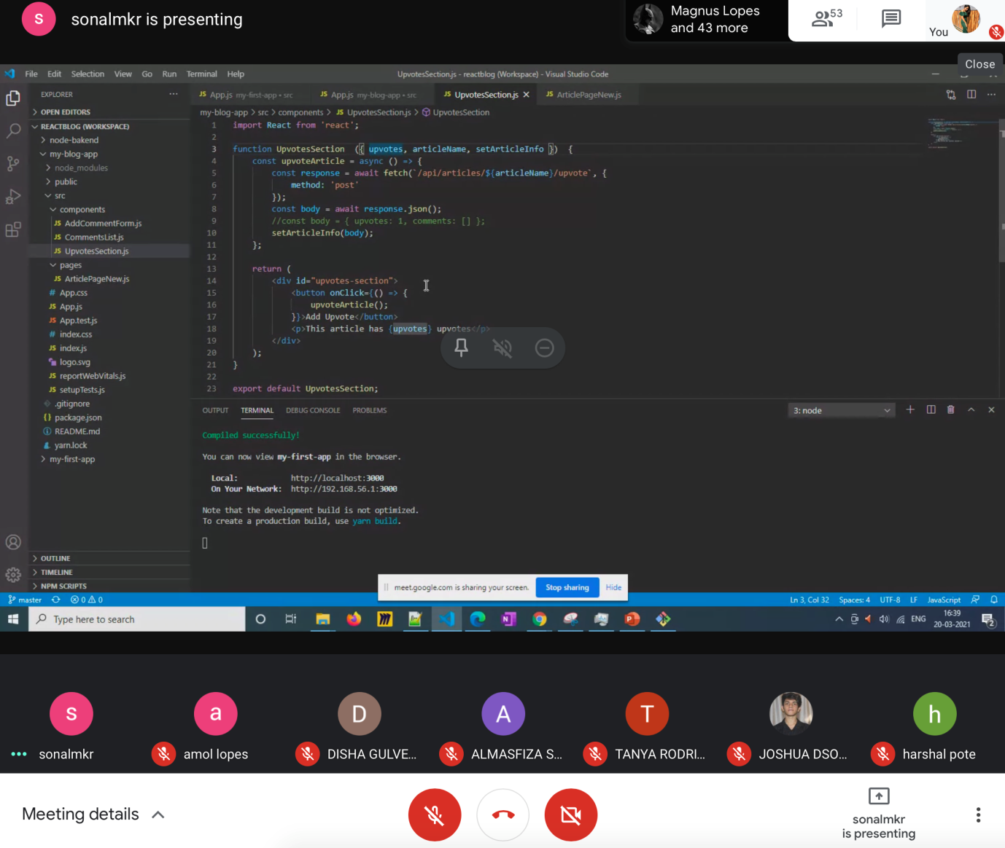

The workshop was then concluded by our Photography head, Ms. Selina by giving a vote of thanks to Ms. Sonali Munagekar.

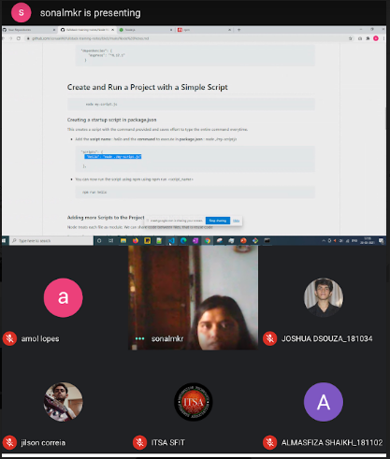

|  |  |  |
| --- | --- | --- |
| **Mrs. Grinal Tuscano** | **Mrs. Shree Jaswal** | **Dr.Joanne Gomes** |
| **(ITSA Coordinator)** | **(ITSA Coordinator)** | **(HOD-IT)** |